Table of Contents
UC1 Real-time GPS Tracking & Map Navigation
UC2 Geofence Audio Trigger with Spam Prevention
UC3 Instant QR Code Activation
UC4 Smart Audio Manager
UC5 Multilingual & Multi-accent Delivery
UC6 Centralized Content Management (CMS)
UC7 Visitor Analytics & Spatial Heatmap

Use Case Number: | UC1
Use Case Name: | Real-time GPS Tracking & Map Navigation
Actor(s): | Visitor
Maturity: | Focused
Summary: | The system tracks the visitor's real-time GPS location (foreground & background), displays their current position on the map, highlights the nearest Point of Interest (POI), and allows viewing detailed information for each point.
Basic Course of Events: | Actor Action |  | System Response
Basic Course of Events: | 1. Launch the mobile application. |  | 2. System initializes the map interface and performs {Check Location Permission}.
Basic Course of Events: |  |  | 3. System retrieves nearby POIs from database/cache and renders markers along with their geofence radii onto the map view.
Basic Course of Events: | 4. The Visitor walks through the tour area. A1 |  | 5. System continuously tracks real-time GPS coordinates and updates the visitor's location indicator (blue dot) on the map.
Basic Course of Events: |  |  | 6. System calculates distances to all POIs, highlights the nearest POI marker, and displays a bottom summary card.
Basic Course of Events: | 7. The Visitor selects a POI marker or taps the bottom summary card. A2 |  | 8. System opens the POI detail screen showing multimedia content, full narrative description, and distance.
Basic Course of Events: | 9. The Visitor taps back to return to the map. |  | 10. System closes the detail screen and restores the active navigation map view. The use case ends.
Alternative Paths: | Path | Actor Action |  | System Response
Alternative Paths: | A1 | App runs in background: The Visitor locks the device or switches apps while moving; |  | the background location service continues logging GPS coordinates at optimized intervals.
Alternative Paths: | A2 | Search POI: The Visitor enters a destination name in the search bar; |  | the map automatically zooms and centers on the targeted POI. Returns to step 8 of Basic Course of Events.
Exception Paths: | Exception | Actor Action |  | System Response
Exception Paths: | E1 | At {Check Location Permission}, if the user denies access, |  | the system prompts a permission dialog with a shortcut to device settings.
Exception Paths: | E2 | If the GPS signal is weak or lost, |  | the system displays a status warning and retains the last known valid coordinate.
Extension Points: | Details / Definition
Check Location Permission | Verifies OS runtime permissions (ACCESS_FINE_LOCATION and ACCESS_BACKGROUND_LOCATION).
Triggers: | The Visitor opens the application or travels inside the heritage site.
Assumptions: | The visitor's mobile device contains a functional GPS receiver.
Preconditions: | Location service is enabled on the device.
Post Conditions: | The visitor's real-time position is updated on the map, and the nearest POI is highlighted.
Business Rules Reference: | Key Features - Feature 1.
Author(s): | Nhóm Đồ Án
Date: | 18-09-2026
Activity Diagram:
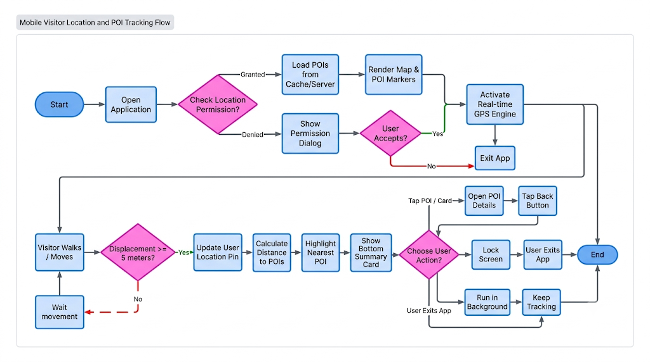

Use Case Number: | UC2
Use Case Name: | Geofence Audio Trigger with Spam Prevention
Actor(s): | Visitor, Location Engine (Sub-actor)
Maturity: | Focused
Summary: | The system automatically triggers and plays multilingual audio narration when a visitor enters a POI's activation radius. It integrates debounce and cooldown mechanisms to prevent audio looping when visitors linger or hover around the perimeter.
Basic Course of Events: | Actor Action |  | System Response
Basic Course of Events: | 1. The Visitor walks into the trigger radius (trigger_radius_meters) of a POI.
Basic Course of Events: |  |  | 2. The Location Engine detects the visitor's updated GPS coordinates.
Basic Course of Events: |  |  | 3. System performs stability verification {Debounce Verification}.
Basic Course of Events: |  |  | 4. System verifies whether the POI is currently on cooldown {Cooldown Check}.
Basic Course of Events: |  |  | 5. System verifies that all playback conditions are met, stops any lower-priority audio currently playing, and automatically loads and plays the corresponding audio file based on the selected language and regional accent.
Basic Course of Events: |  |  | 6. The Audio Player interface (Mini-Player / Full Player) updates to display the currently playing POI.
Basic Course of Events: | 7. The Visitor listens to the narration until completion or moves away. A1, A2
Basic Course of Events: |  |  | 8. System records the playback timestamp into the history list (lastPlayedMap) and starts the cooldown timer (e.g., 300 seconds).
Basic Course of Events: |  |  | 9. System automatically logs an anonymous visit event and dispatches it to the backend analytics server. The use case ends.
Alternative Paths: | Path | Actor Action |  | System Response
Alternative Paths: | A1 | Manual Pause or Track Change: The Visitor taps Pause or manually selects another attraction from the interface; |  | the system stops automatic playback and records the actual listening duration.
Alternative Paths: | A2 | Visitor Remains Stationary After Playback: The narration completes while the visitor remains within the geofence area; |  | because the cooldown timer is active, the system suppresses automatic re-triggering to preserve a quiet environment.
Exception Paths: | Exception | Actor Action |  | System Response
Exception Paths: | E1 | GPS Boundary Jitter (Near-Boundary Noise): At {Debounce Verification}, if the coordinates fluctuate repeatedly across the perimeter within a short window, |  | the system drops the signal and avoids playing audio.
Exception Paths: | E2 | Active Cooldown Period: At {Cooldown Check}, if the elapsed time since the last playback is less than cooldown_seconds, |  | the system ignores the trigger event.
Extension Point: | Details / Definition
Debounce Verification | Verifies and ensures GPS coordinates remain stable inside the radius for at least 3 seconds prior to triggering.
Cooldown Check | Evaluates the formula CurrentTime - LastPlayedTime > CooldownDuration.
Triggers: | The visitor's GPS coordinates cross into an active POI trigger radius.
Assumptions: | Audio files or TTS narration scripts are available on the system.
Preconditions: | The application is running (foreground or background), and auto-play mode is enabled.
Post Conditions: | The audio narration is played exactly once per visit session; the cooldown timer is activated.
Business Rules Reference: | Key Features - Feature 2
Author(s): | Project Team
Date: | September 19, 2026
Activity Diagram:
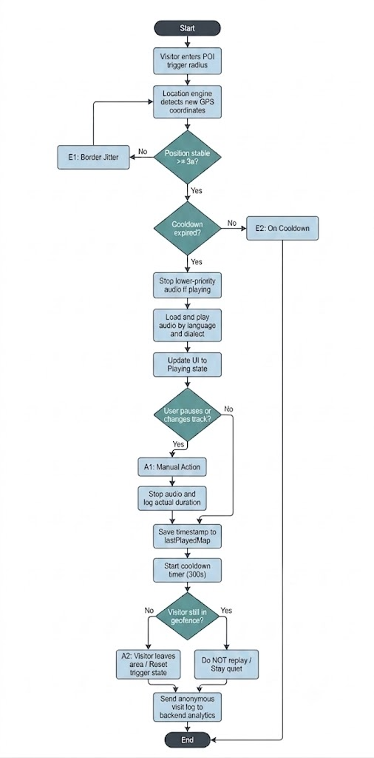

Use Case Number: | UC3
Use Case Name: | Instant QR Code Activation
Actor(s): | Visitor
Maturity: | Focused
Summary: | The visitor scans a physical QR code mounted on signboards, transit stops, or exhibits using the in-app camera scanner. The system immediately retrieves, loads, and plays the corresponding audio narration without relying on or waiting for GPS satellite acquisition.
Basic Course of Events: | Actor Action |  | System Response
Basic Course of Events: | 1. The Visitor taps the "Scan QR" button on the top navigation bar. |  | 2. The system opens the scanner view, requests device camera access, and performs {Check Camera Permission}.
Basic Course of Events: |  |  | 3. The system turns on the camera viewfinder with a centered scanning targeting frame.
Basic Course of Events: | 4. The Visitor points the camera at the physical QR code on the site signpost. A1 |  | 5. The optical engine scans and decodes the unique identifier (qr_code_key) from the QR code image.
Basic Course of Events: |  |  | 6. The system closes the scanner viewfinder and sends an API request to fetch content: GET /api/v1/pois/by-qr/{qrKey}.
Basic Course of Events: |  |  | 7. The backend verifies the key and returns the POI bundle (title, images, narration script, and audio URL matching the visitor's preferred language and dialect).
Basic Course of Events: |  |  | 8. The system transitions the interface directly to the Full Audio Player screen and starts audio playback immediately.
Basic Course of Events: | 9. The Visitor listens to the narration and browses visual illustrations. A2 |  | 10. The system logs an anonymous playback entry with trigger_method = "qr_code" and syncs historical metrics. The use case ends.
Alternative Paths: | Path | Actor Action |  | System Response
Alternative Paths: | A1 | Low-Light Condition: The Visitor taps the Flashlight toggle button on the camera interface; the system activates the device torch to illuminate the physical code. Control returns to Step 5 of the Basic Course of Events.
Alternative Paths: | A2 | Cancel / Back Action: The Visitor taps the "Cancel" or "Back" button while inside the scanner viewfinder; the system stops the camera stream and returns the user to the Map View. The use case ends.
Exception Paths: | Exception | Actor Action |  | System Response
Exception Paths: | E1 | Camera Permission Denied: At {Check Camera Permission}, if the user denies camera access, the system presents an alert dialog: "Camera permission is required to scan QR codes", with a button leading directly to OS Application Settings.
Exception Paths: | E2 | Invalid / Unrecognized QR Code: After Step 5, if the decoded string does not match the system standard or the API returns HTTP 404 (Not Found), the system displays an error prompt: "Invalid or unrecognized QR code", and keeps the scanner open for another attempt.
Exception Paths: | E3: | Network Unavailable: If the device has no network connection and the media is not cached locally, the system alerts: "Network connection error. Unable to load narration data."
Extension Point | Details / Definition
Check Camera Permission | Verifies and requests OS runtime camera hardware permissions (android.permission.CAMERA / iOS NSCameraUsageDescription).
Triggers: | The Visitor decides to scan a physical code at an exhibit, stop, or in areas with poor GPS reception (indoors, shaded corridors).
Assumptions: | Physical QR codes are clearly printed, clean, and placed at an accessible height.
Preconditions: | The visitor's device has a functional camera lens.
Post Conditions: | The target POI narration begins playback instantly, and a QR-triggered session event is logged.
Business Rules Reference: | Key Features - Feature 3
Author(s): | Project Team
Date: | September 19, 2026
Activity Diagram:
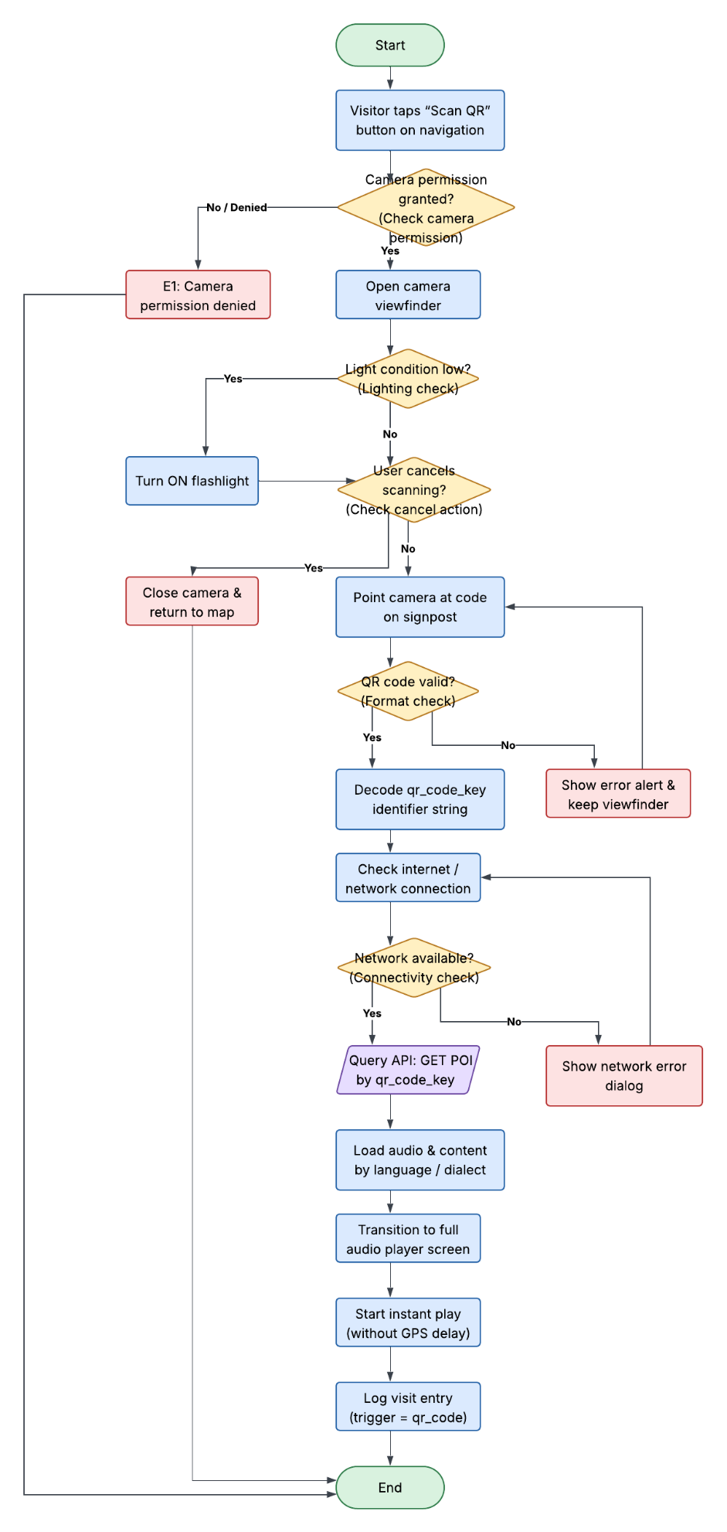

Use Case Number: | UC4
Use Case Name: | Manage Audio Playback and Queue (Smart Audio Manager)
Actor(s): | Visitor, System
Maturity: | Focused
Summary: | The system coordinates audio commentary playback for the visitor via a priority queue mechanism, resolves playback conflicts among nearby POIs, prevents redundant playback, and automatically ducks or pauses audio when higher-priority alerts occur.
Basic Course of Events: | Actor Action | System Response
Basic Course of Events: |  | 1. The system detects an audio trigger event for a specific POI (via Geofence entry or QR code scan).
Basic Course of Events: |  | 2. The system checks the current queue status and verifies duplicate constraints: if the audio for this POI is actively playing or was played within the cooldown period, the event is dismissed. E1
Basic Course of Events: |  | 3. The system compares priority levels between the newly triggered POI and the currently playing audio.
Basic Course of Events: |  | 4. The system enqueues the audio track based on its assigned priority and prepares to play the next pending track.
Basic Course of Events: |  | 5. The system presents the audio playback interface on the screen (displaying POI name, progress bar, and play/pause controls).
Basic Course of Events: | 6. The Visitor listens to the narration and optionally interacts with playback controls (pause, resume, skip). A1
Basic Course of Events: |  | 7. The audio track completes playback; the system automatically starts the next item in the queue or returns to idle mode. The use case ends.
Alternative Paths: | A1. From the playback interface, the visitor has the ability to pause and resume the narration. When paused, the system retains the current timestamp. When resumed, playback continues from the paused timestamp and returns to step 7 of the Basic Course of Events.
Alternative Paths: | A2. If an emergency alert or high-priority announcement is triggered, the system automatically lowers the volume (audio ducking) or pauses the ongoing narration to broadcast the urgent message. After the alert finishes, the system restores the narration volume or resumes playback at step 6 of the Basic Course of Events.
Exception Paths: | E1. At step 2, if the detected POI is already playing, currently pending in the queue, or within the debounce/cooldown window, the system discards the trigger and maintains existing playback.
Extension Points: | None
Triggers: | The Visitor enters a POI geofence boundary or successfully scans a POI QR code.
Assumptions: | Device multimedia audio is enabled and speaker/earphones function properly.
Preconditions: | The tour guide application is running in either the foreground or background.
Post Conditions: | The audio queue is updated according to priority, and the audio narration plays smoothly without collision.
Reference: | Feature 4 (Smart Audio Manager), System Architecture Documentation
Author(s):
Date:
Activity Diagram:
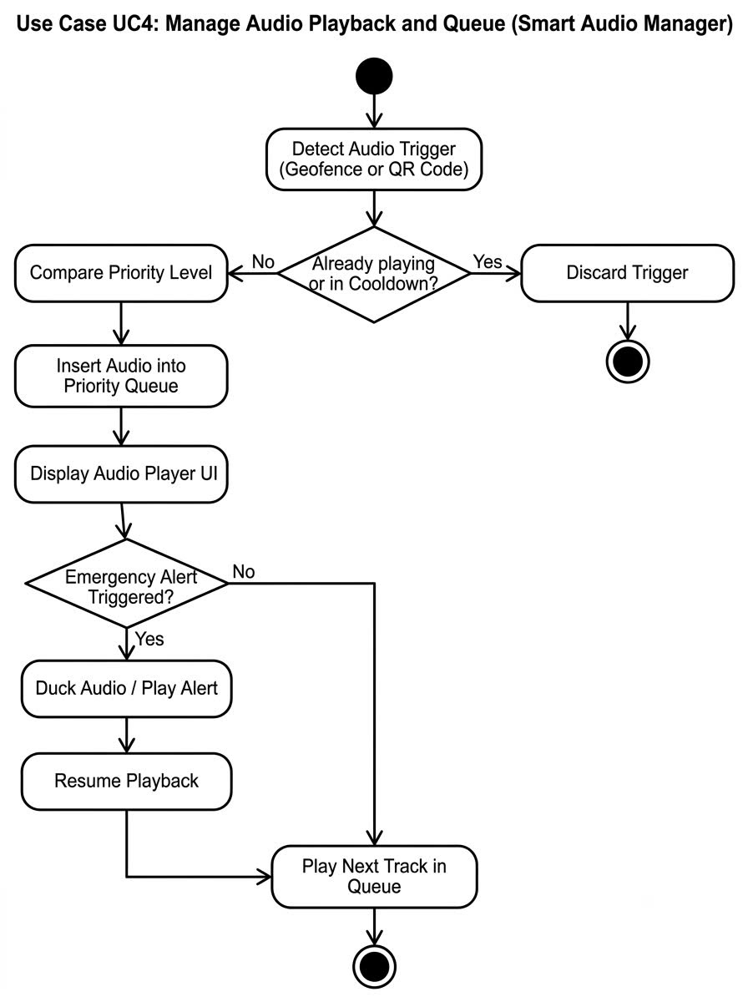

Use Case Number: | UC5
Use Case Name: | Deliver Multilingual and Multi-accent Audio
Actor(s): | Visitor
Maturity: | Focused
Summary: | Provides flexible audio narration tailored to the visitor's preferred language and regional accent (Northern / Central / Southern Vietnamese; or foreign language accents), delivering pre-recorded studio audio or dynamically synthesizing speech via Text-to-Speech (TTS) when recordings are unavailable.
Basic Course of Events: | Actor Action | System Response
Basic Course of Events: | 1. The Visitor navigates to the Audio & Language Settings screen in the application.
Basic Course of Events: |  | 2. The system displays available languages along with regional accent options (Northern, Central, and Southern for Vietnamese; relevant accents for foreign languages).
Basic Course of Events: | 3. The Visitor selects their preferred language and regional accent, then confirms the selection.
Basic Course of Events: |  | 4. The system stores the visitor's voice preferences in local storage.
Basic Course of Events: |  | 5. When a POI playback request is received, the system checks whether a pre-recorded professional audio file matching the chosen configuration is available. A1
Basic Course of Events: |  | 6. The system fetches/streams the matching pre-recorded audio file and forwards it to the Smart Audio Manager for playback.
Basic Course of Events: |  | 7. The system confirms successful loading and begins audio output. The use case ends.
Alternative Paths: | A1. At step 5, if no pre-recorded audio file exists for the chosen language/accent combination:  - The system retrieves the text script corresponding to the POI.  - The system invokes the Text-to-Speech (TTS) engine to synthesize the speech dynamically matching the requested language and accent.  - The system streams the generated audio to the Smart Audio Manager and proceeds to step 7 of the Basic Course of Events.
Exception Paths: | E1. If the device has no internet connection to fetch the audio file or contact the cloud TTS engine, and offline data is not cached, the system displays an alert message "Audio unavailable offline" and presents the written transcript on screen for the visitor to read manually.
Extension Points: | None
Triggers: | The Visitor modifies language/accent settings, or a POI audio playback is initiated.
Assumptions: | The device supports standard audio codecs and multimedia playback.
Preconditions: | The Visitor has opened the mobile tour guide application.
Post Conditions: | The POI narration is delivered to the visitor using their selected language and regional accent.
Reference: | Feature 5 (Multilingual & Multi-accent Delivery), System Architecture Documentation
Author(s):
Date:
Activity Diagram:
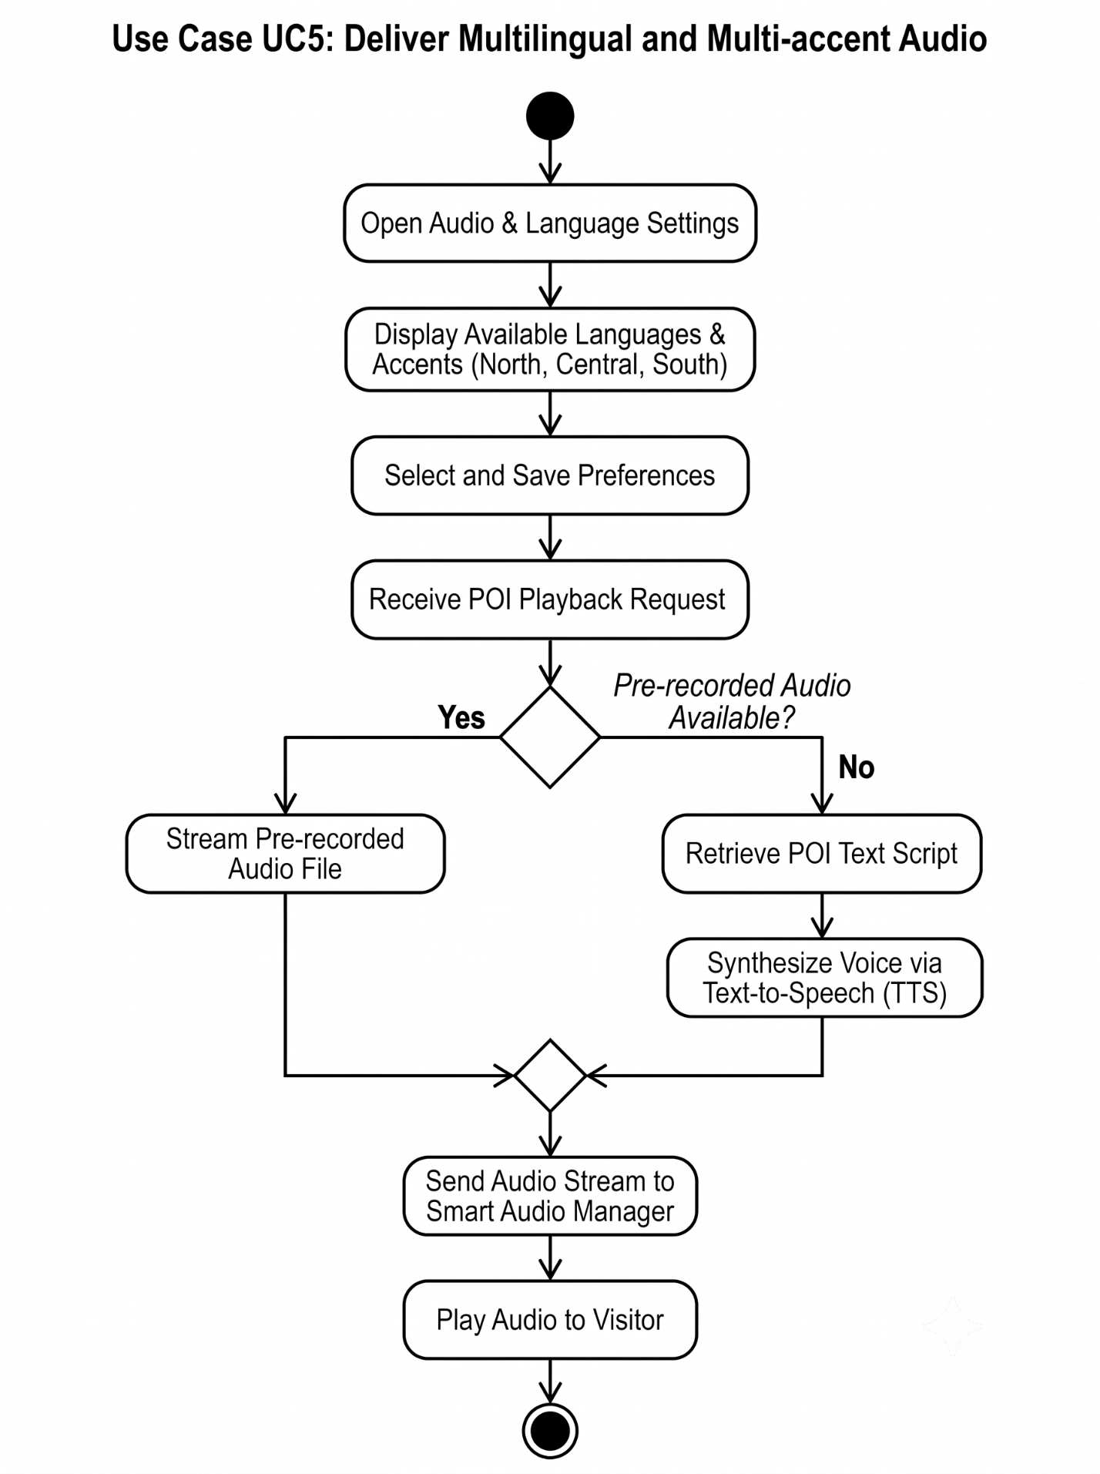

 | 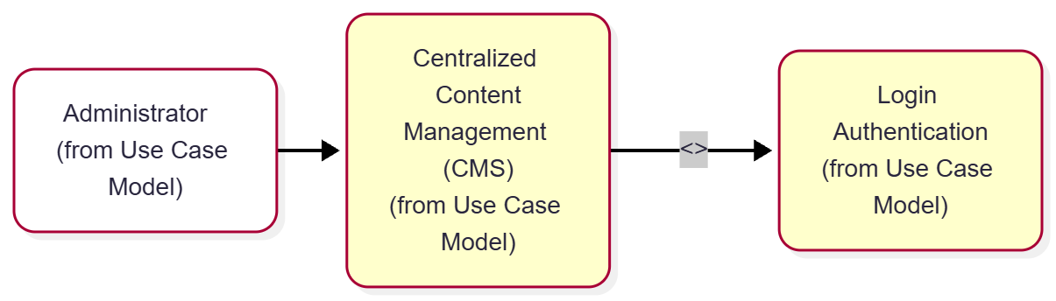
 | Use Case Number: |  | UC6
 | Use Case Name: |  | Centralized Content Management (CMS)
 | Actor (s): |  | Administrator
 | Maturity: |  | Focused
 | Summary: |  | Allows the administrator to manage system content, including adding, editing, and deleting POI coordinates, trigger radius, images, TTS scripts, tour links, and audio files.
 | Basic Course of Events: |  | Actor Action |  |  | System Response
 |  |  | 1. The Administrator logs into the CMS web portal and accesses the Content Management section.
 |  |  |  |  |  | 2. The system retrieves and displays the list of POIs, trigger radii, images, TTS scripts, tour links, and audio files.
 |  |  | 3. The Administrator adds or updates POI details (coordinates, radius, images, TTS scripts, audio files, tour links).
 |  |  | 4. The Administrator clicks Save / Publish.
 |  |  |  |  |  | 5. The system validates input data formats, spatial coordinates, and audio file limits. E1, E2, E3
 |  |  |  |  |  | 6. The system updates the central database and displays a "Content updated successfully" message.
 | Alternative Paths: |  | A1. Delete or Unpublish Content
 |  |  | Actor Action |  |  | System Response
 |  |  | 1. The Administrator selects a POI, audio file, or tour link to remove.
 |  |  |  |  |  | 2. The system prompts for deletion confirmation.
 |  |  | 3. The Administrator confirms the deletion.
 |  |  |  |  |  | Return to step 2 of the Basic Course of Events.
 |  |  | A2. The Administrator has the ability to "Cancel" changes to return the content form to its previously saved state. Returns to step 2 of Basic Course of Events.
 |  |  | A3. The Administrator has the ability to preview the generated TTS script audio before publishing.
 | Exception Paths: |  | E1. The system detects invalid GPS coordinates or out-of-range radius value. The system displays an error message: "Invalid location parameters." Returns to step 3 of Basic Course of Events.  E2. The uploaded audio file exceeds size limits or uses an unsupported format. The system displays an error message: "Invalid audio file format or size." Returns to step 3 of Basic Course of Events.  E3. The TTS script contains invalid characters or exceeds character limits. The system displays an error message: "TTS script error." Returns to step 3 of Basic Course of Events.
 | Extension Points: |  | Preview Generated TTS Audio  Verification and audio playback generation of the input script prior to storing in the server database A3
 | Triggers: |  | Administrator accesses the CMS web platform to manage POIs or media content.
 | Assumptions: |  | The Administrator possesses active administrative privileges to modify central content.
 | Preconditions: |  | The Administrator is successfully authenticated into the CMS admin portal.
 | Post Conditions: |  | POI coordinates, radii, images, TTS scripts, tour links, and audio files are updated in the system database.
 | Reference: Business Rules |  | BR_CMS_Media_01, BR_POI_Spatial_02
 | Author(s): |  | Student Team
 | Date: |  | 09-20-2026
Activity Diagram: Next Page
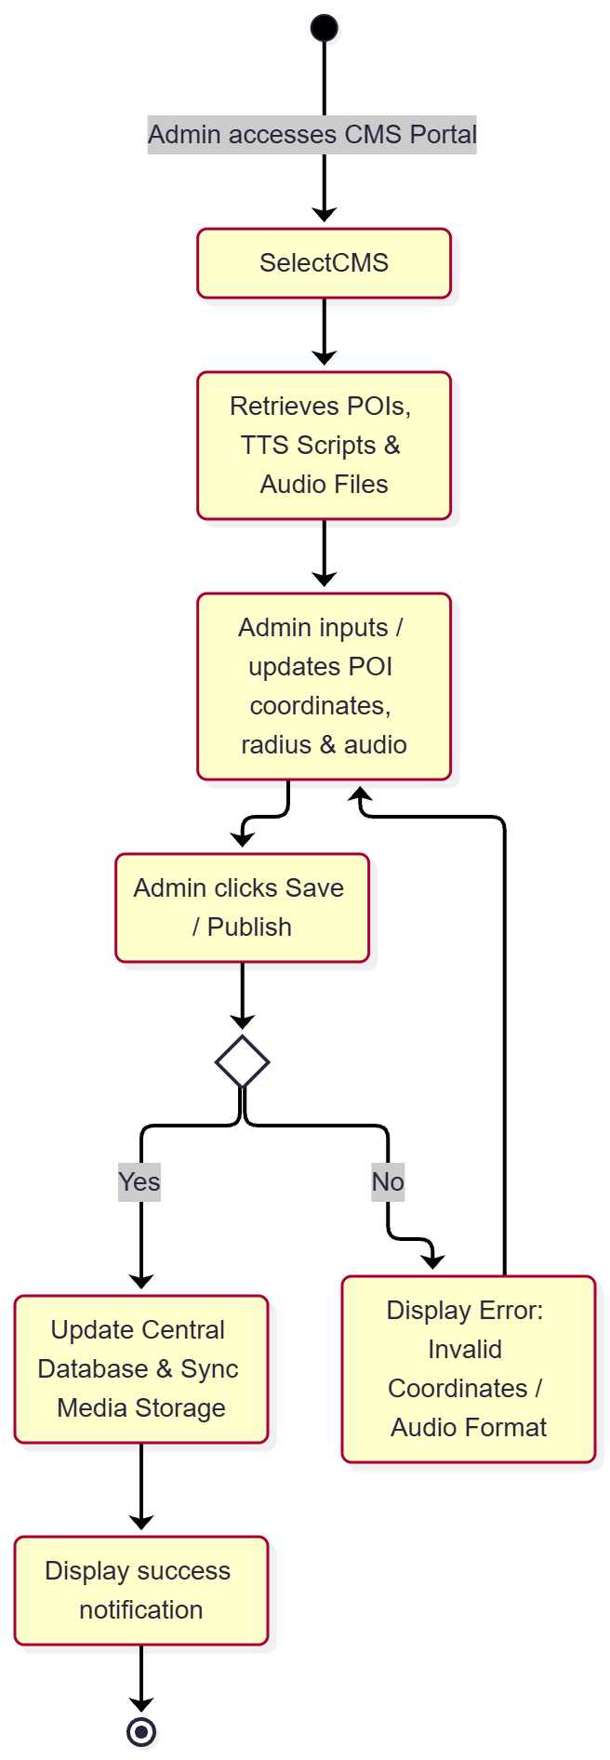

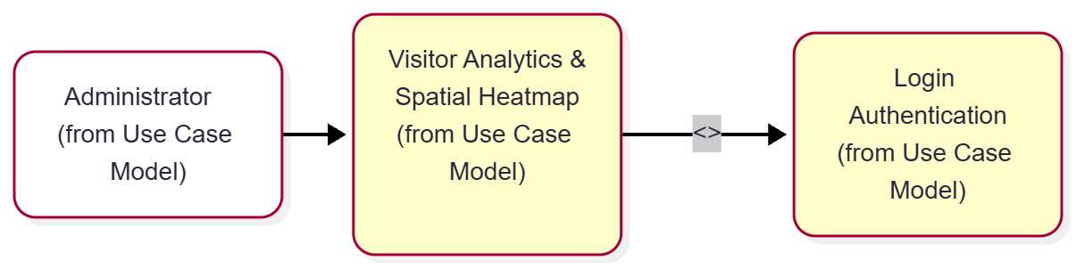
Use Case Number: |  | UC7
Use Case Name: |  | Visitor Analytics & Spatial Heatmap
Actor (s): |  | Administrator
Maturity: |  | Focused
Summary: |  | Collects anonymized movement logs and audio playback counts, analyzes top-listened POIs and average listening time, and visualizes movement flows via a spatial heatmap.
Basic Course of Events: |  | Actor Action |  | System Response
 |  | 1. The Administrator navigates to the Analytics & Heatmap module in the CMS.
 |  |  |  | 2. The system retrieves anonymized movement logs and playback data from the database.
 |  | The Administrator selects a timeframe or tour filter for analysis.
 |  |  |  | 4. The system aggregates top-listened POIs and average listening time metrics.
Alternative Paths: |  | A1. Export Analytics Summary Report
 |  | Actor Action |  |  | System Response
 |  | 1. The Administrator clicks "Export Analytics Report" (PDF/Excel).
 |  |  |  |  | 2. The system generates and downloads the summary report file containing top POIs and movement stats.
Exception Paths: |  | E1. No log data available for the selected timeframe or tour region. The system displays a notice: "No activity logs found for the selected filter." Control returns to step 3 of Basic Course of Events.
Extension Points: |  | None
Triggers: |  | Administrator opens the analytics dashboard to monitor visitor metrics or spatial heatmaps.
Assumptions: |  | All collected location logs and audio playback records are strictly anonymized to protect user privacy.
Preconditions: |  | The Administrator is logged into the system and background services are actively logging anonymized spatial events.
Post Conditions: |  | Spatial heatmaps, top POI rankings, and visitor metrics are displayed on the dashboard.
Reference: Business Rules: |  | BR_Analytics_01, BR_Privacy_Anonymity_02
Author(s): |  | Student Team
Date: |  | 09-20-2026
Activity Diagram: Next Page
